Salmon Spiders
By Geir Kjensmo

The name ”spider” in fly-tying is a description of a way of tying flies, like the British Yorkshire Spiders, and this article describes a way of tying salmon flies on very thin needle tubes.
I started tying salmon flies like this a couple of years ago on standard salmon trebles and instantly had success in my salmon fishing in the Norwegian river Orkla. This way of tying is also influenced by the Scandinavian style of tying “Temple Dog” patterns.
Now with the availability of stainless needle tubes from Greys of Kilsyth, http://www.graysofkilsyth.com/
the descriptive name “spider” came to my mind. I use the 1.8mm tubes on thicker leader tippets than possible with the 1.5mm tubes.
The way of tying this kind of flies, resembles the original spiders for trout and grayling.
The proportions of the flies is much better, using needle tubes, and the sink rate of these stainless tubes are a tad better than aluminum “bottle necks”.
The way of tying also has in mind dressings and materials that ensure that the fly sinks from the very beginning of the drift. The hair wing, crossbreed fox tail, is tied temple dog style, but sparsely use of hair.
The patters don’t have any body except the shiny, silvery tube. On colorful patterns for cold, murky or high water, I often thread the special fine diameter silicone tubing inside a little section of orange standard silicone tubing, to give a colorful “butt”.
Materials else used are colored spey hackle or colored mallard flank for supporting (and add mobility) the wing (behind the wing) and colored guinea body feathers for front hackle.
Optional I use some crystal splash pearl fibers also in the wing. It’s a simple way of tying, but I find the flies very effective and tie variants of Cascade, Ally’s Scrimp, Green Highlander and Thunder&Ligthning to mention a few. And in various sizes, of course.
When fishing, the long spey hackle/ mallard flank and the “temple dog” style wing, gives the fly better mobility than any other design I know, in most current speeds.

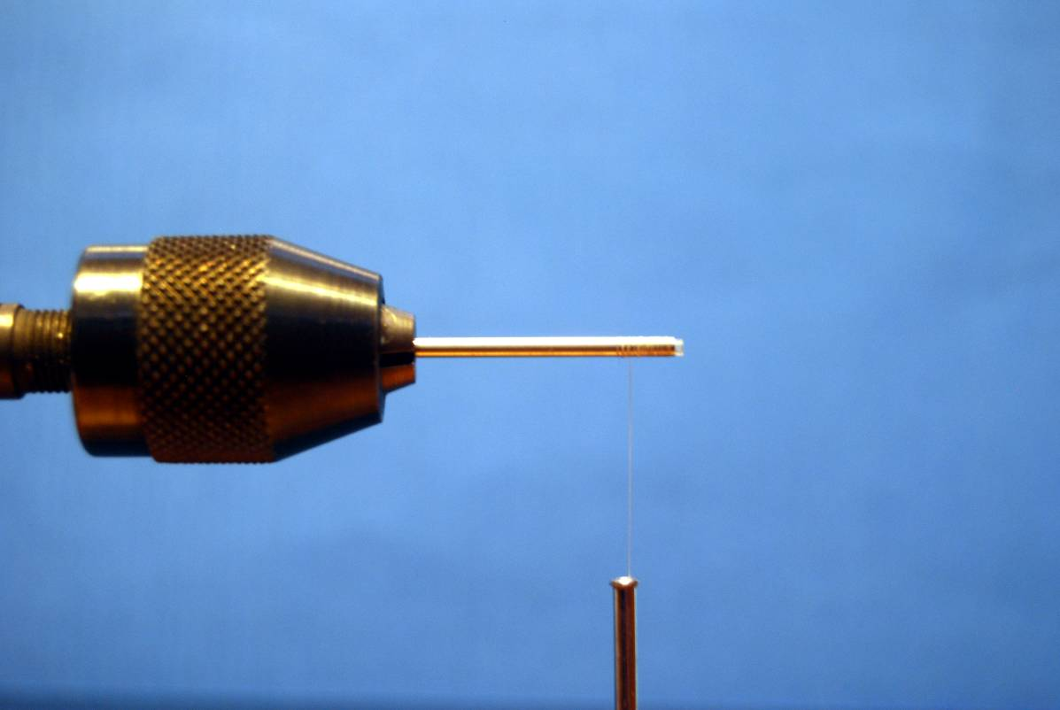
Needle tube in chuck like vice, wind the tread 5mm back from the front.
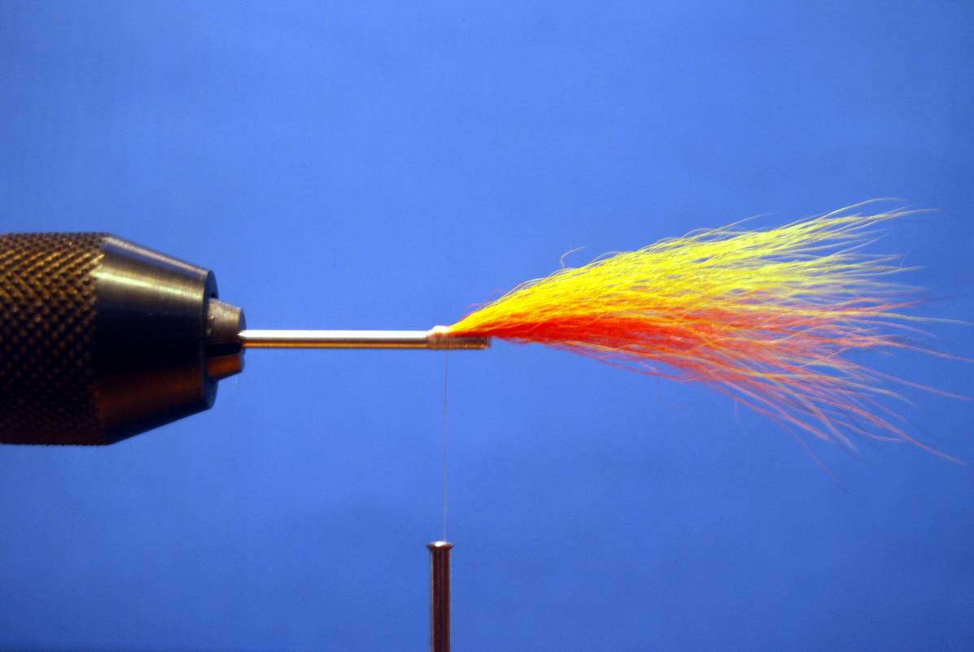
The wing of fox tail is tied forwards

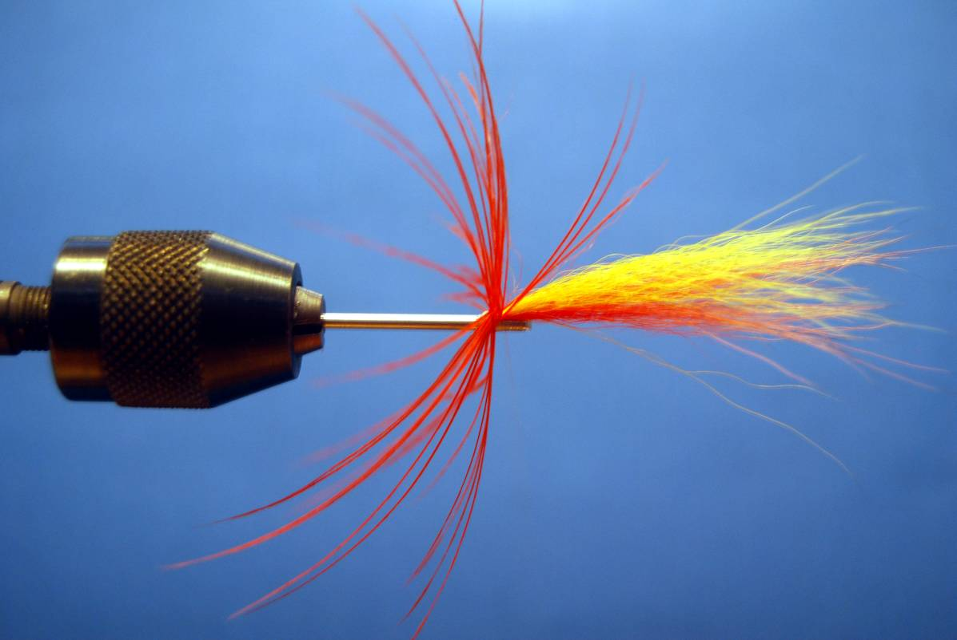
Spey hackle or mallard flank, is tied behind the wing.
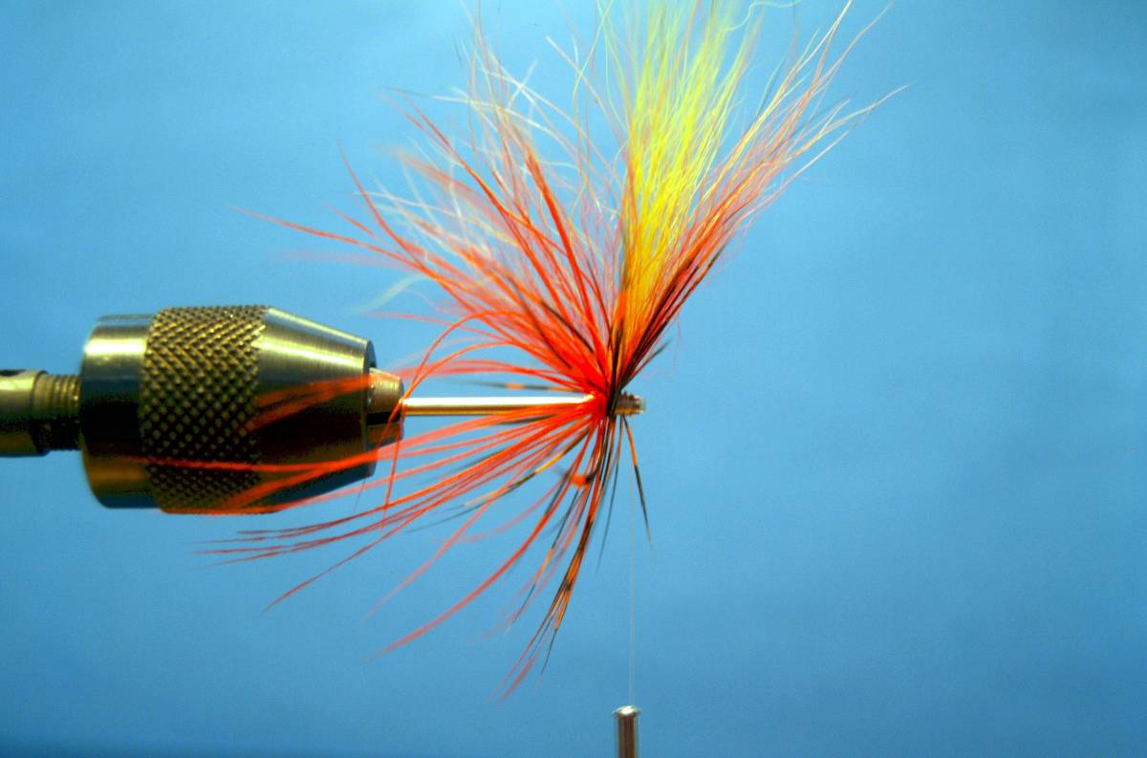
Tie in one guinea body feather, in this case orange. Tie it close when raising the hair wing.
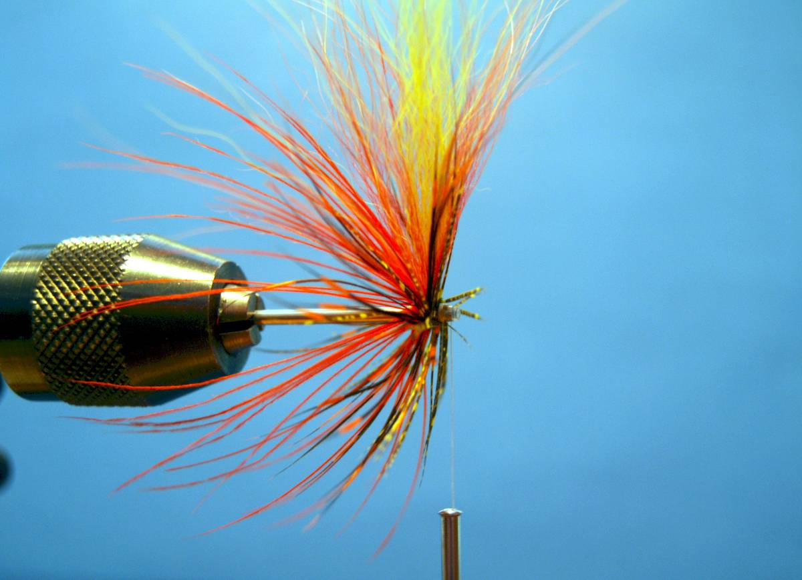
Tie in the second guinea body feather, in this case yellow. Still, tied tight to help raising the wing.
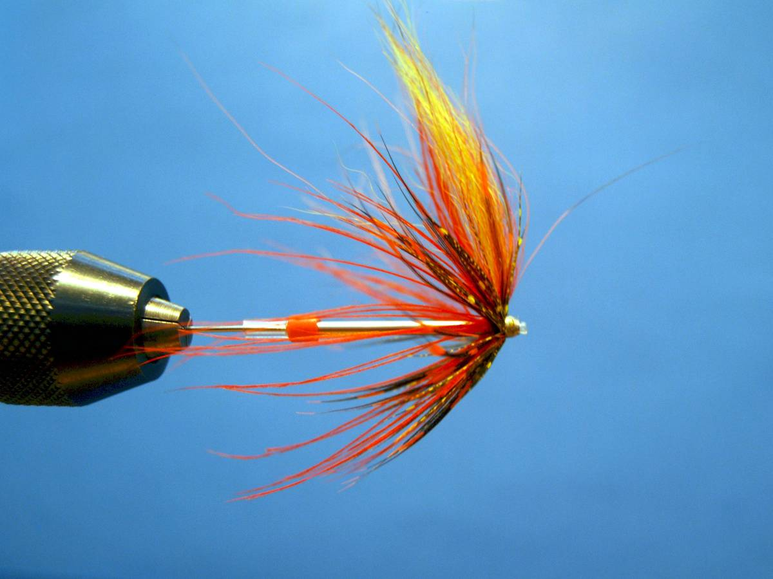
Make a head and finish the fly. Note the thin silicone first thread inside a small section of
standard orange silicone, before fixing the silicone on the tube.
This to give the fly a colorful “butt” on some of the patterns.

